**Manav Rachna International Institute of Research and Studies**

**School of Computer Applications**

**Department of Computer Applications**

| **Submitted By** | |
| --- | --- |
| **Student Name** | **Deepak Mangla** |
| **Roll No** | **24/SCA/BCA(AI&ML)/015** |
| **Programme** | **Programme (Bachelor of Computer Applications, BCA(AI&ML)** |
| **Semester** | **1st** |
| **Section/Group** | **B** |
| **Department** | **Computer Applications** |
| **Session / Batch** | **2024-27** |
|  | |
| **Submitted To** | |
| **Faculty Name** | **Mrs. Sakshi Mam** |

|  | **SCHOOL OF COMPUTER APPLICATIONS** |
| --- | --- |

| **4.5CA152C01: WEB TECHNOLOGIES LAB**  **INDEX** | | | | | | | |
| --- | --- | --- | --- | --- | --- | --- | --- |
| **S. No** | **Program** | **CO** | **BTL** | **Date of Submission** | **Date of Evaluation** | **Remarks** | **Signature** |
|  | **Introduction to HTML** |  |  |  |  |  |  |
| 1. | Create a simple HTML page using basic tags. | CO1 |  |  |  |  |  |
| 2. | Create a web page that displays your name to the screen. | CO1 |  |  |  |  |  |
| 3. | Create a web page and show the output from 1 to 10 in separate lines. | CO1 |  |  |  |  |  |
| 4. | Create a web page and show the output from 1 to 10 in separate lines, each number being in different color. | CO1 |  |  |  |  |  |
| 5. | How do I make a picture as a background on my web pages? | CO1 |  |  |  |  |  |
| 6. | Create a web page to print a paragraph with 4-5 sentences, each sentence shall have a different font. | CO1 |  |  |  |  |  |
| 7. | Write HTML code to print a paragraph that is description of a book, it shall include the title of the book, its author name; name and title should be underlined and all adjectives shall be bold and Italics. | CO1 |  |  |  |  |  |
| 8. | Write HTML code to print your name using Heading tag, every letter shall be of different heading size. | CO1 |  |  |  |  |  |
| 9. | Write HTML code to print the sequence of numbers 1-20. Each number shall be in different line with number 2 next to it as subscript, an equal sign and the result. | CO1 |  |  |  |  |  |
| 10. | Write HTML code to display an image with border of size with width 200, height 200 pixels, leaving Hspace and Vspace of your choice with image hanging in the right side on the screen. | CO1 |  |  |  |  |  |
| 11. | Write HTML code to create a web page with heading. The heading shall be displayed at the top-center of the page and the image shall be at the centre, just below the heading. | CO1 |  |  |  |  |  |
| 12. | Write HTML code using Multimedia tags. | CO1 |  |  |  |  |  |
| 13. | Create a Table using Rowspan and Colspan taking example of student Record. | CO1 |  |  |  |  |  |
| 14. | Write HTML code using table tag <table> and cellpadding and cell spacing as its attributes. | CO1 |  |  |  |  |  |
| 15. | Create unordered, ordered and definition Lists taking example of your subjects in MCA IST, IInd and IIIrd Semester. | CO1 |  |  |  |  |  |
| 16. | Write HTML code using <frameset> and <frame> tag with all its attributes | CO1 |  |  |  |  |  |
| 17. | Write HTML code to design a form in HTML using controls and buttons such as Textbox, Text area, password, submit button, browse button, drop-down menu | CO1 |  |  |  |  |  |
| 18. | Write HTML code to design a Registration Form in HTML. | CO1 |  |  |  |  |  |
| 19. | Write HTML code to design a student admission Form in HTML. | CO3 |  |  |  |  |  |
| 20. | Create a proper home page of your own using any components and styles. | CO3 |  |  |  |  |  |
| 21. | Write HTML code for including Local hyperlinking in a web page. | CO3 |  |  |  |  |  |
| 22. | Write HTML code for including Inter hyperlinking in a web page. | CO3 |  |  |  |  |  |
| 23. | Write HTML code for including External hyperlinking in a web page. | CO3 |  |  |  |  |  |
| 24. | Write code to show External CSS with HTML code | CO3 |  |  |  |  |  |
| 25. | Write code to show Internal CSS with HTML code. | CO3 |  |  |  |  |  |
| 26. | Write code to show Inline CSS with HTML code. | CO3 |  |  |  |  |  |
| 27. | Write a program to add two numbers using form in JavaScript. | CO2 |  |  |  |  |  |

Question 1) Create a simple HTML page using basic tags.

Input-

<html>

<head>

<title> Student Information </title>

</head>

<body>

<h4> Basic Tags</h4>

</body>

</html>

Output-

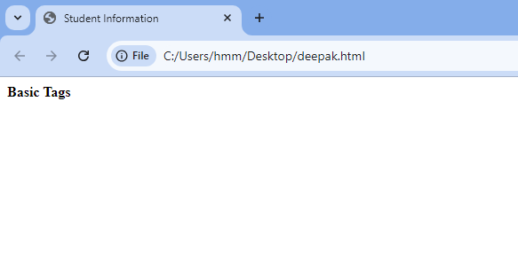

Question 2) Create a web page that display your name to the screen.

Input-

<html>

<head>

<title> Student Information </title>

</head>

<body>

<h4> Student Name – Deepak Mangla </h4>

</body>

</html>

Output-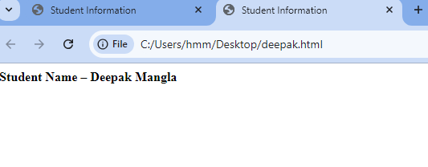

Question 3) Create a web page and show the output from 1 to 10 in separate lines.

Input-

<html>

<head>

<title> Student Information </title>

</head>

<body>

<h4> Student Name – Deepak Mangla </h4>

<p> 1 </p>

<p> 2 </p>

<p> 3 </p>

<p> 4 </p>

<p> 5 </p>

<p> 6 </p>

<p> 7 </p>

<p> 8 </p>

<p> 9 </p>

<p> 10 </p>

</body>

</html>

Output –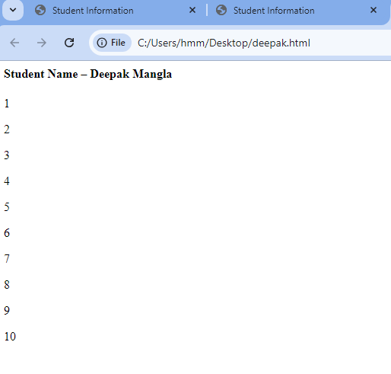

Question 4) Create a web page and show the output from 1 to 10 in separate lines, each number being in different color.

Input-

<html>

<head>

<title> Student Information </title>

</head>

<body>

<h4> Student Name – Deepak Mangla </h4>

<p style="color: red;"> 1 </p>

<p style="color: purple;"> 2 </p>

<p style="color: orange;"> 3 </p>

<p style="color: pink;"> 4 </p>

<p style="color: green;"> 5 </p>

<p style="color: blue;"> 6 </p>

<p style="color: brown;"> 7 </p>

<p style="color: yellow;"> 8 </p>

<p style="color: violet;"> 9 </p>

<p style="color: black;"> 10 </p>

</body>

</html>

Output -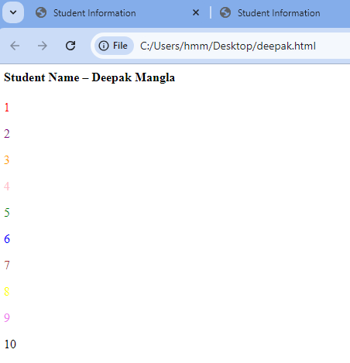

Question 5) How do I make a picture as a background on my web pages ?

Input-

<html>

<head>

<title> Student Information </title>

</head>

<body style="background-color: powderblue;">

<h3 style="color: Tomato;"> Adding picture to background </h3>

<img src="https://www.google.com/url?sa=i&url=https%3A%2F%2Fdl.flipkart.com%2Fdl%2Fmahadev-mahakal-bholenath-lord-shiva-religious-waterproof-vinyl-sticker-poster-24-inch-x-36-inch-btcan3020-3-fine-art-print%2Fp%2Fitmd11beea039f3e%3Fpid%3DPOSG9AGXASPGMW7F%26cmpid%3Dproduct.share.pp%26_refId%3DPP.0b5f3bf5-136b-449f-9365-c2545e51b8de.POSG9AGXASPGMW7F&psig=AOvVaw29Z9ZlyPIUeu2fUolKNnAx&ust=1725279889952000&source=images&cd=vfe&opi=89978449&ved=0CBIQjRxqFwoTCJD8vtneoYgDFQAAAAAdAAAAABAN">

</body>

</html>

Output-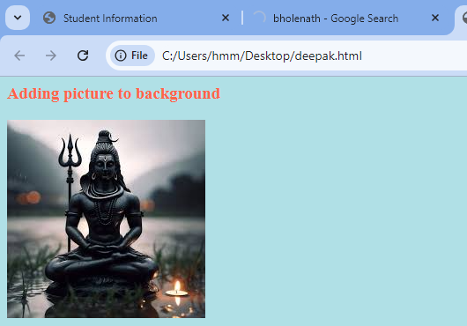

Question 6) Create a web page to print a paragraph with 4-5 sentences , each sentences shall have a different font.

Input-

<html>

<head>

<title> Student Information </title>

</head>

<body style="background-color: powderblue;">

<h5 style="Font-Family: Cursive;"> This is Paragraph one </h5>

<h4 style="Font-Family: Fantasy;"> This is Paragraph two </h4>

<h3 style="Font-Family: Helvetica;"> This is Paragraph three </h3>

<h2 style="Font-Family: Courier New;"> This is Paragraph four </h2>

<h1 style="Font-Family: Verdana New;"> This is Paragraph five</h1>

</body>

</html>

Output –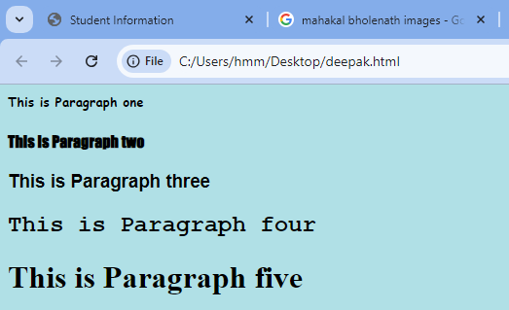

Question 7) Write HTML code to print a paragraph that is description of a book, it shall include the title of the book ,its author name and title should be underlined and all adjectives shall be bold and Italics.

Input-<html>

<head>

<title> Student Information </title>

</head>

<body style="background-color: powderblue;">

<p>Book name - <b><u><i> Harry Potter and the Philosopher's Stone</b></u></i> Author

name - <b><u><i>J. K. Rowling</b></u></i></p>

</body>

</html>

Output –

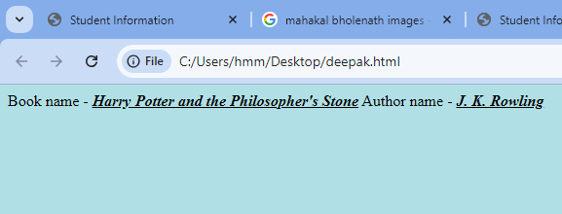

Question 8) Write HTML code to print your name using Heading tag, every letter shall be of different heading size.

Input-

<html>

<head>

<title> Heading Tag </title>

</head>

<body style="background-color:powderblue;">

<h1>D</h1>

<h2>E</h2>

<h3>E</h3>

<h4>P</h4>

<h5>A</h5>

<h6>K</h6>

</body>

</html>

Output –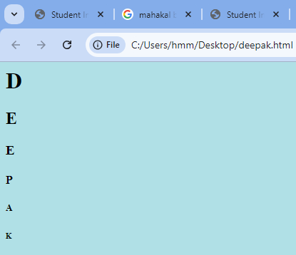

Question 9) Write HTML code to print the sequence of number 1-20.Each number shall be in different line with number 2 next to it as subscript , an equal sign and the result.

Input-

<html>

<head>

<title> Heading Tag </title>

</head>

<body style="background-color:powderblue;">

<p>1<sub>2</sub> = 2</p>

<p>2<sub>2</sub> = 4</p>

<p>3<sub>2</sub> = 6</p>

<p>4<sub>2</sub> = 8</p>

<p>5<sub>2</sub> = 10</p>

<p>6<sub>2</sub> = 12</p>

<p>7<sub>2</sub> = 14</p>

<p>8<sub>2</sub> = 16</p>

<p>9<sub>2</sub> = 18</p>

<p>10<sub>2</sub> = 20</p>

<p>11<sub>2</sub> = 22</p>

<p>12<sub>2</sub> = 24</p>

<p>13<sub>2</sub> = 26</p>

<p>14<sub>2</sub> = 28</p>

<p>15<sub>2</sub> = 30</p>

<p>16<sub>2</sub> = 32</p>

<p>17<sub>2</sub> = 34</p>

<p>18<sub>2</sub> = 36</p>

<p>19<sub>2</sub> = 38</p>

<p>20<sub>2</sub> = 40</p>

</body>

</html>

Output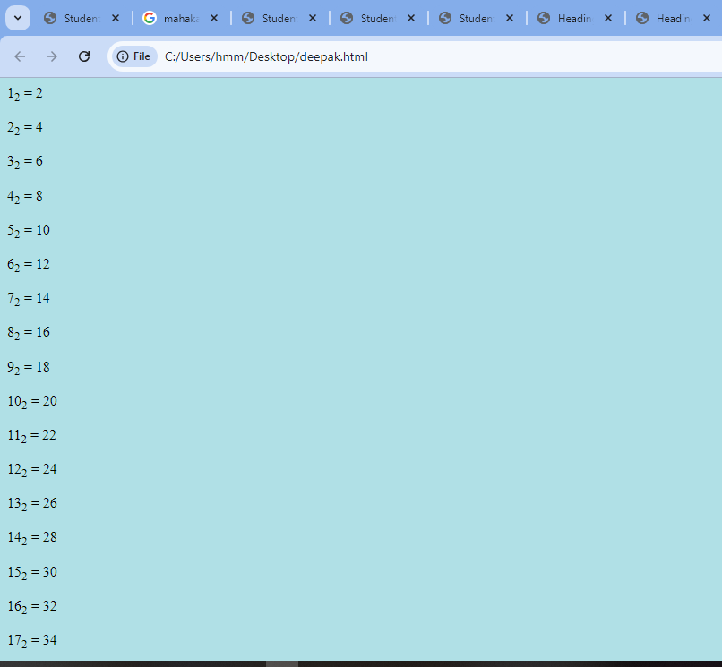

Ques 10) Write html code to display an image with border of size with width 200,height 200 pixels, leaving Hspace and Vspace of your choice with image hanging in the right side on the screen.

Input-

<HTML>

<head>

<title>Image Display</title>

<style>

img {

border: 2px solid black;

width: 200px;

height: 200px;

display: block;

margin-left: auto;

margin-right: 0;

margin-top: 20px;

margin-bottom: 20px; }

</style>

</head>

<body>

<img src="https://i.pinimg.com/originals/cb/21/2f/cb212f92878b0a5d511ed98f9ddbf1a8.jpg"Sample Image">

</body>

</html>

Output-

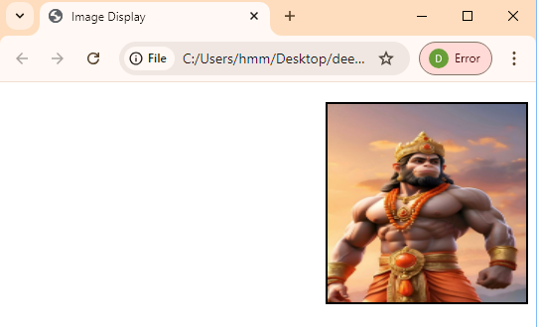

Ques 11) Write HTML code create a web page with heading . The heading shall be displayed at the top-center of the page and the image shall be at the center ,just below the heading.

Input-

-<html>

<head>

<title>Centered Heading and Image</title>

<style>

body {

margin: 0;

font-family: Arial, sans-serif;

text-align: center;

justify-content: center;

align-items: center;

</style>

</head>

<body>

<h1>The THE PRIME MINISTER OF INDIA 2024</h1>

<img src="https://www.pmindia.gov.in/wp-content/uploads/2024/06/Know-the-PM-Thumbnail.jpg">

</body>

</html>

Output-

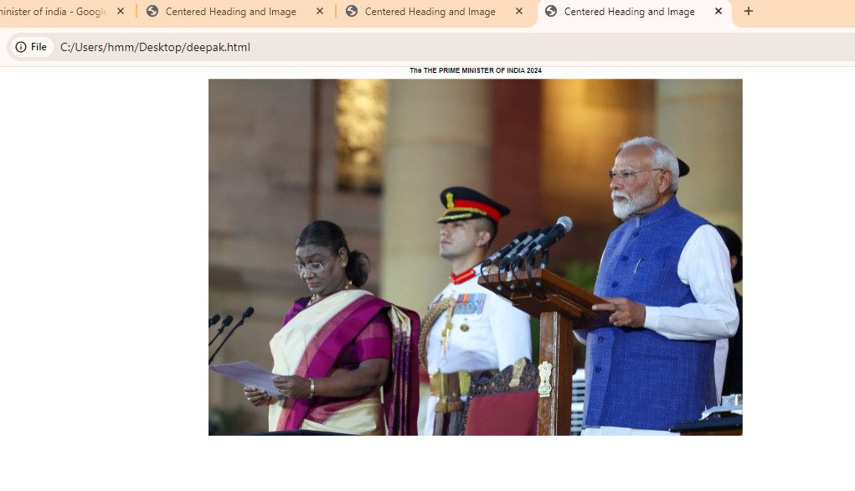

Q12. Write HTML code using Multimedia tags.

Input:

<html>

<head>

<title> multimedia tags</title>

</head>

<body>

<h1> multimedia tags: </h1>

<h1>img</h1>

<center>

<img src="C:\Users\Riaz\Downloads/OIP.jpg" alt="scenery" height="450" , width="450"/>

<h1> audio </h1>

<audio src="C:\Users\USER\Downloads/ringtone.mp3" controls/>

</body>

</html>

Output-

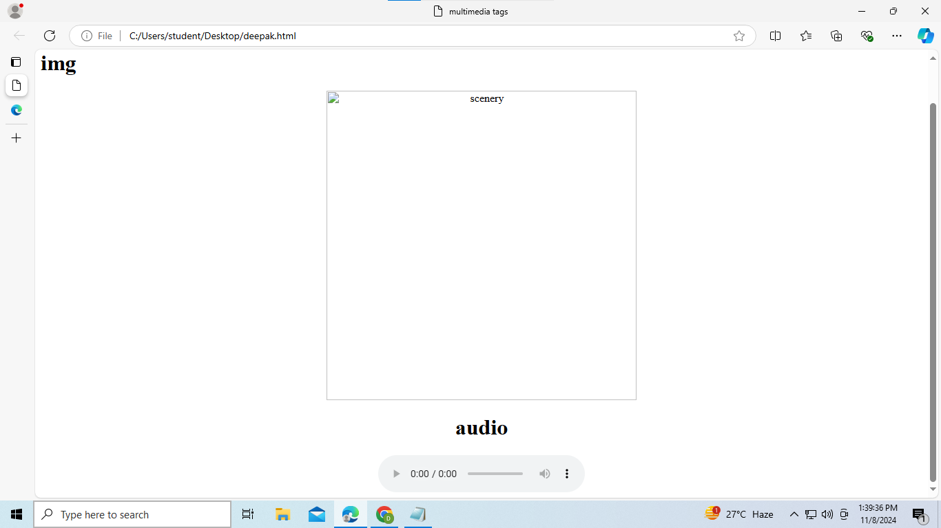

Ques 13) Create a Table using Rowspan and Colspan taking example of student Record.

Input:

<html>

<head></head>

<body>

<table border='4pt'>

<tr>

<th colspan='2'>Name</th>

<th>class</th>

<th>school</th></tr>

<tr>

<td rowspan='2'>mahatma</td>

<td rowspan='2'>gandhi</td>

<td> 11</td>

<td>mvps</td></tr>

<tr>

<td>A</td></tr>

<tr>

<td rowspan='2'>shree</td>

<td rowspan='2'>krishna</td>

<td> 3</td>

<td>nvps</td></tr>

<tr>

<td>B</td></tr>

<tr>

<tr>

<td rowspan='2'>bheem</td>

<td rowspan='2'>sen</td>

<td> J</td>

<td>avps</td></tr>

<tr>

<td>A</td></tr>

</table>

</body>

</html>

Output:

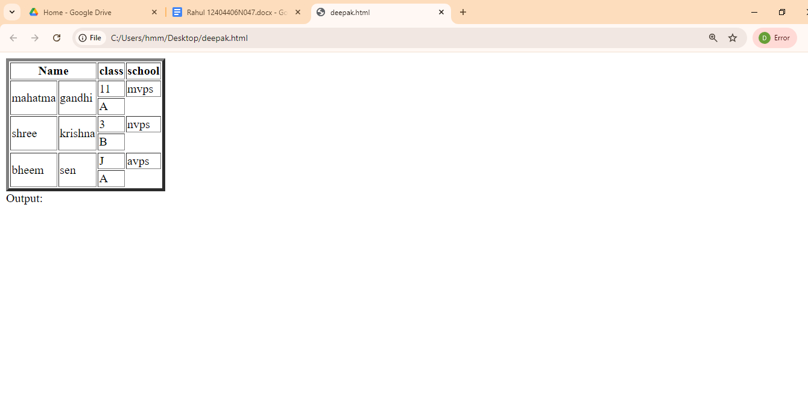

Q14.Write HTML code using table tag <table> and cellpadding and cell spacing as its attributes.

 Input:

<html>

<head></head>

<body>

<table border="2pt" cellspacing="5pt" cellpadding="5pt">

<tr>

<th>S.no</th>

<th>Roll no.</th>

<th>Name</th>

<th>Address</th></tr>

<tr>

<td>1</td>

<td>123</td>

<td>ABC</td>

<td>FBD</td></tr>

<tr>

<td>2</td>

<td>456</td>

<td>XYZ</td>

<td>delhi</td></tr>

<tr>

<td>3</td>

<td>789</td>

<td>PQR</td>

<td>gurgaon</td></tr>

</table>

</body>

</html>

Output-

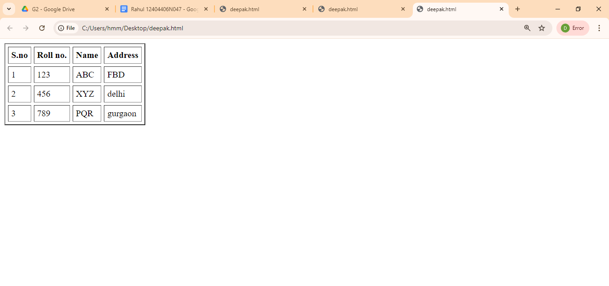

Q15. Create unordered, ordered and definition Lists taking example of your subjects in MCA IST, IInd and IIIrd Semester.

Input :

<html>

<head></head>

<body>

<h3> Subjects in BCA sem 1</h3>

<ol>

<li>Web technologies</li>

<ul>

<li>introduction to Networks</li>

<li>introduction to e-mail</li>

<li>introduction to html</li>

</ul>

<li>Introduction to IT & programming in C</li>

<ul>

<li>Input output devices</li>

<li>compilers,Interpreters,assemblers</li>

<li>various programs in C</li>

</ul>

<li>Mathematics</li>

<ul>

<li>matrices</li>

<li>surds and insurdes</li>

<li>trigonometry</li><ul><ol>

</body>

</html>

Output-

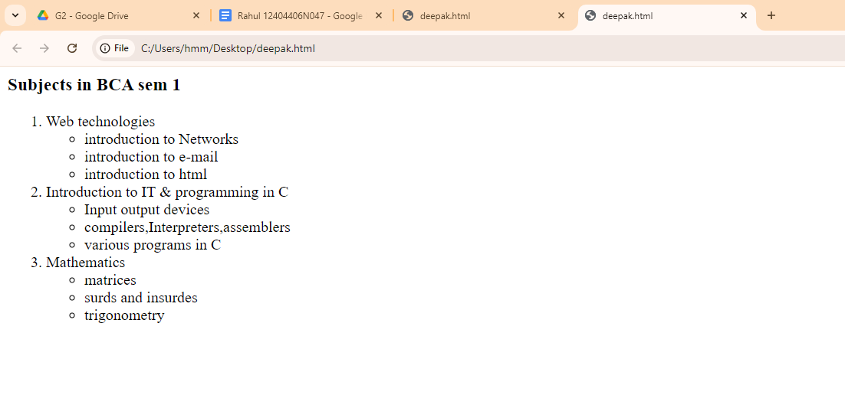

Q 16)Write HTML code using <frameset> and<frame> tag with all its attributes.

input-

<html>

<body>

<fieldset><legend><font color='Blue'>REGISTRATION FORM</font></legend></feildset>

<form><bgcolor='red'>

<label>First Name:</label>

<input type='text'name='name' id='name'><br><br>

<label>Last Name:</label>

<input type='text' name='name' id='name'><br><br>

<label>Date Of Birth:</label>

<input type='date'><br><br>

<label>Gender:</label>

<input type='radio' name='gender' value='Male' >

<label>Male</label>

<input type='radio' name='gender' value='Female' >

<label>Female</label><br><br>

<label>Contact No:</label>

<input type='textbox'><br><br>

<label>Email Address:</label>

<input type='email' placeholder='Enter email address'><br><br>

<label>Any other Information:</label><br>

<textarea rows='4' cols='20'>Enter your full info</textarea>

<br><br>

<input type='submit' value='Submit'>

<input type='reset' value='Reset'>

</form>

</body>

</html>

Output-

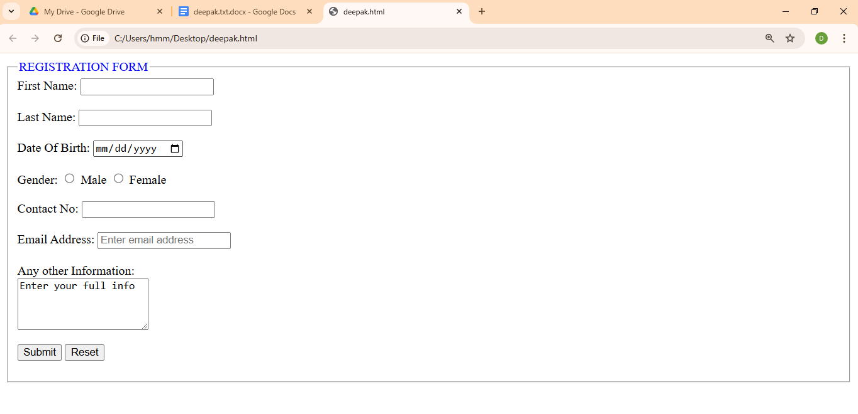

Q 17)Write HTML code to design a form in html using controls and buttons such as textbox,textarea , password, submit button, browse button, drop-down menu.

Input-

<html>

<body>

<fieldset><legend><font color='Blue'>APPLICATION FORM</font></legend></feildset>

<form><bgcolor='red'>

<label>First Name:</label>

<input type='text'name='name' id='name'>

<label>Last Name:</label>

<input type='text' name='name' id='name'><br><br>

<label>Date Of Birth:</label>

<input type='date'><br><br>

<label>Gender:</label>

<input type='radio' name='gender' value='Male' >

<label>Male</label>

<input type='radio' name='gender' value='Female' >

<label>Female</label><br><br>

<label>Contact No:</label>

<input type='textbox'><br><br>

<label>Email Address:</label>

<input type='email' placeholder='Enter email address'><br><br>

<label>Position Available</label><br>

<input type='checkbox' value='Assistant HR'>

<label>Assistant HR</label><br>

<input type='checkbox' value='Junior developer'>

<label>Junior developer</label><br>

<input type='checkbox' value='Senior developer'>

<label>Senior developer</label><br>

<input type='checkbox' value='Web designer'>

<label>Web designer</label><br><br>

<label>Any other Information:</label><br>

<textarea rows='4' cols='20'>Enter your full info</textarea>

<br><br>

<input type='submit' value='Submit'>

<input type='reset' value='Reset'>

</form>

</body>

</html>

Output-

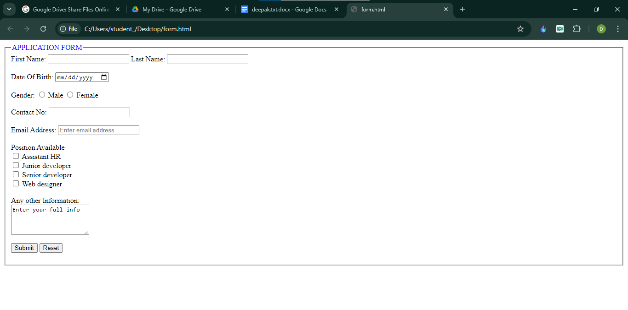

Ques 18) Write HTML code to design a registration form in HTML.

input-

<html>

<body>

<fieldset><legend><font color='Blue'>REGISTRATION FORM</font></legend></feildset>

<form><bgcolor='red'>

<label>First Name:</label>

<input type='text'name='name' id='name'><br><br>

<label>Last Name:</label>

<input type='text' name='name' id='name'><br><br>

<label>Date Of Birth:</label>

<input type='date'><br><br>

<label>Gender:</label>

<input type='radio' name='gender' value='Male' >

<label>Male</label>

<input type='radio' name='gender' value='Female' >

<label>Female</label><br><br>

<label>Contact No:</label>

<input type='textbox'><br><br>

<label>Email Address:</label>

<input type='email' placeholder='Enter email address'><br><br>

<label>Any other Information:</label><br>

<textarea rows='4' cols='20'>Enter your full info</textarea>

<br><br>

<input type='submit' value='Submit'>

<input type='reset' value='Reset'>

</form>

</body>

</html>

Output-



Ques 19) Write HTML code to design a Student admission form in HTML.

input-

<html>

<body>

<fieldset><legend><font color='Blue'>STUDENT ADMISSION FORM</font></legend></feildset>

<form><bgcolor='red'>

<label>First Name:</label>

<input type='text'name='name' id='name'><br><br>

<label>Last Name:</label>

<input type='text' name='name' id='name'><br><br>

<label>Date Of Birth:</label>

<input type='date'><br><br>

<label>Gender:</label>

<input type='radio' name='gender' value='Male' >

<label>Male</label>

<input type='radio' name='gender' value='Female' >

<label>Female</label><br><br>

<label>Contact No:</label>

<input type='textbox'><br><br>

<label>Email Address:</label>

<input type='email' placeholder='Enter email address'><br><br>

<label>Address</label>

<textarea rows='4' cols='20'></textarea><br><br>

<label>Course</label>

<input type='text'><br><br>

<label>Father Name</label>

<input type='text'><br><br>

<label>Mother Name</label>

<input type='text'><br><br>

<input type='submit' value='Submit'>

<input type='reset' value='Reset'>

</form>

</body>

</html>

Output-

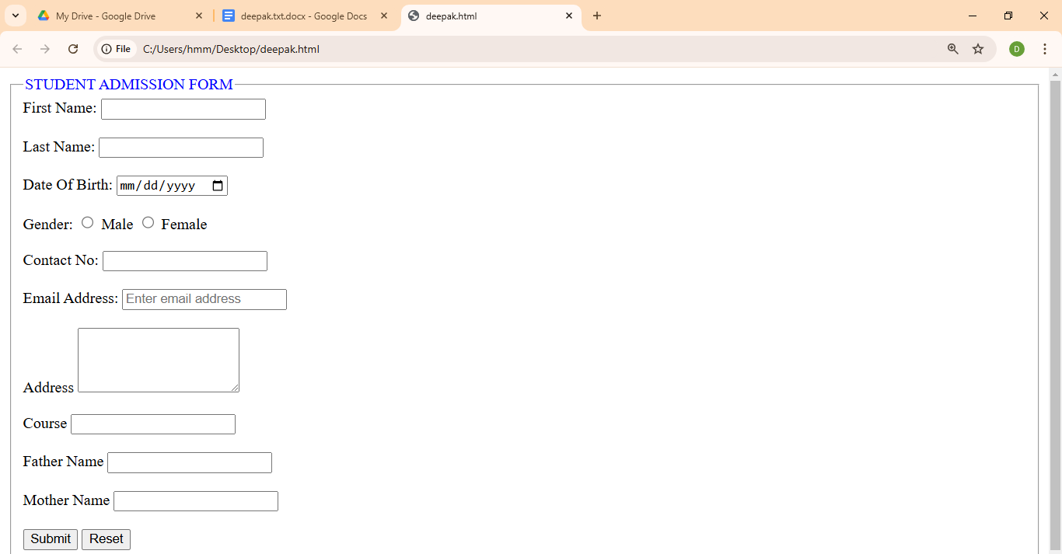

Ques 20)Create a proper home page of your own using any components and styles.

input-

<html>

<body>

<p>I am normal</p>

<p style="color:red;">I am red</p>

<p style="color:blue;">I am blue</p>

<p style="font-size:50px;">I am big</p>

<h1 style="background-color:powderblue;">This is a heading</h1>

<p style="background-color:tomato;">This is a paragraph.</p>

<h1 style="color:blue;">This is a heading</h1>

<p style="color:red;">This is a paragraph.</p>

<h1 style="text-align:center;">Centered Heading</h1>

<p style="text-align:center;">Centered paragraph.</p>

</body>

</html>

Output-

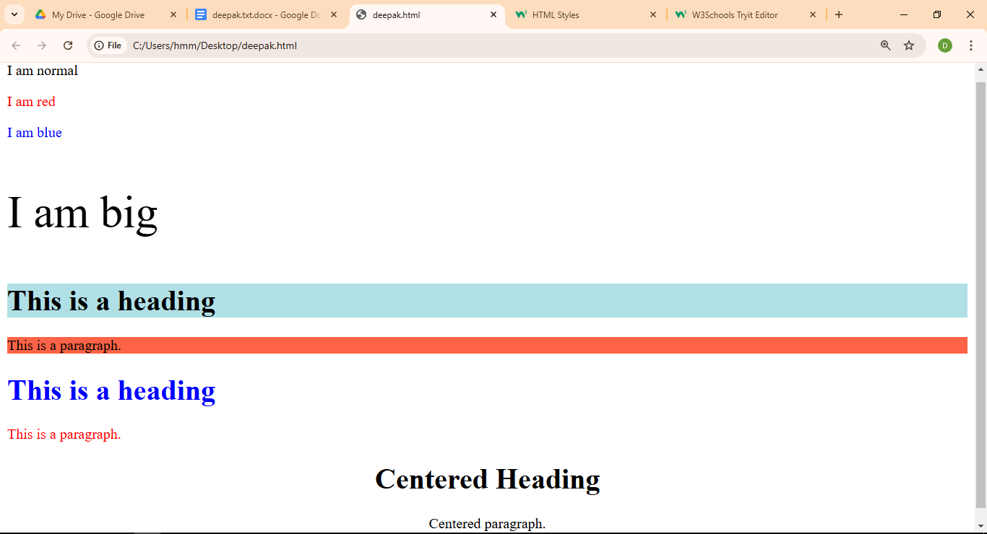

Q21. Write HTML code for including Local hyperlinking in a web page.

Input:

<!DOCTYPE html>

<html>

<head>

<title>Local Hyperlinking Example</title>

</head>

<body>

<h1>Local Hyperlinking</h1>

<p>This is a sample paragraph with a local hyperlink to another section within the same page.</p>

<a href="#section2">Jump to Section 2</a>

<h2 id="section2">Section 2</h2>

<p>This is the content of Section 2.</p>

</body>

</html>

Output:

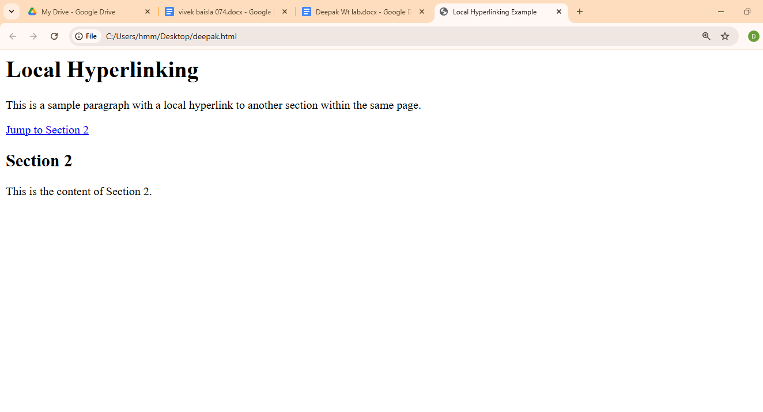

Q22. Write HTML code for including Inter hyperlinking in a web page.

Input:

<!DOCTYPE html>

<html>

<head>

<title>Inter Hyperlinking Example</title>

</head>

<body>

<h1>Inter Hyperlinking</h1>

<p>This is a sample paragraph with an inter-page hyperlink to another HTML file.</p>

<a href="page2.html">Go to Page 2</a>

</body>

</html>

Output:

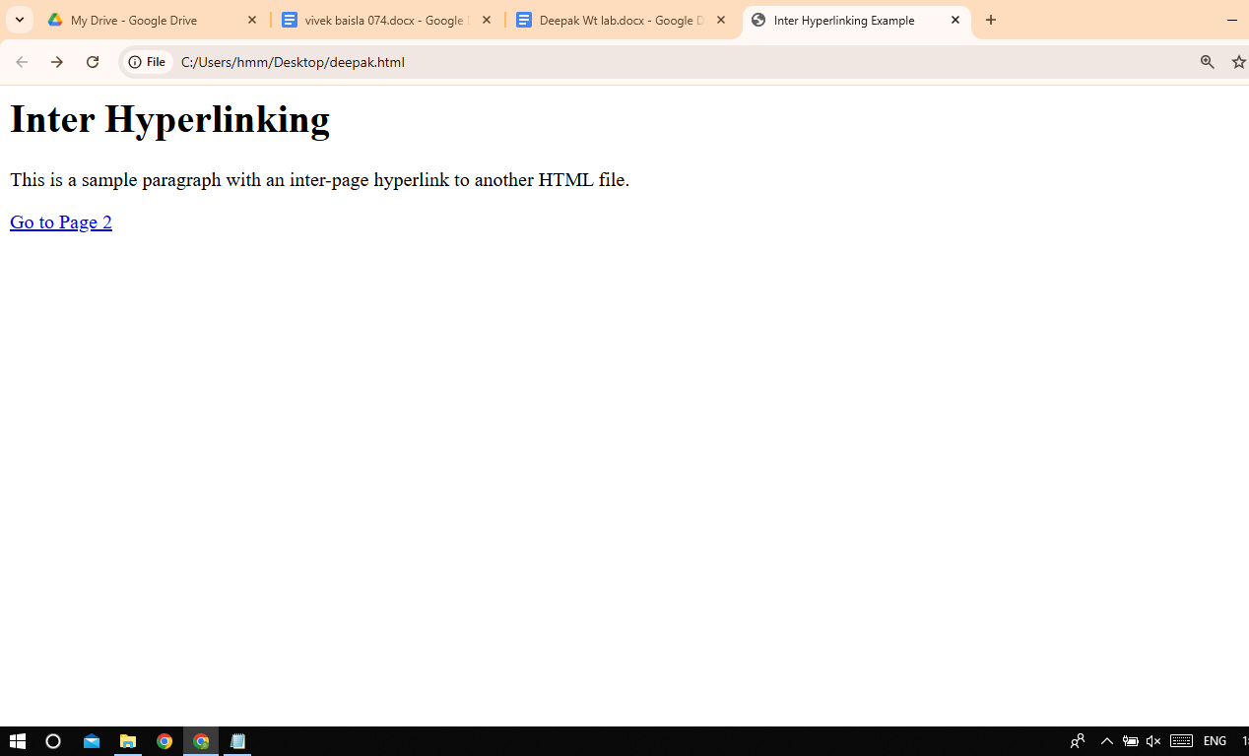

Q23. Write HTML code for including External hyperlinking in a web page.

Input:

<!DOCTYPE html>

<html>

<head>

<title>External Hyperlinking Example</title>

</head>

<body>

<h1>External Hyperlinking</h1>

<p>This is a sample paragraph with an external hyperlink to another website.</p>

<a href="https://www.example.com">Visit Example Website</a>

</body>

</html>

Output:

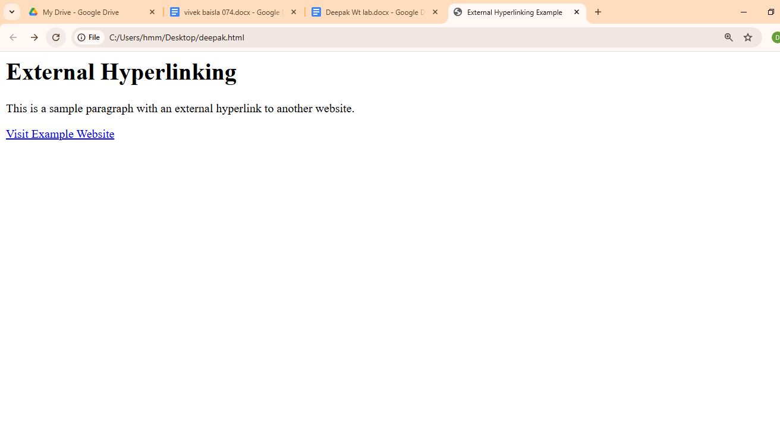

Q24. Write code to show External CSS with HTML code.

Input:

<!DOCTYPE html>

<html>

<head>

<title>External CSS Example</title>

<link rel="stylesheet" href="styles.css">

</head>

<body>

<h1>Hello, World!</h1>

<p>This is a paragraph styled with external CSS.</p>

</body>

</html>

Output:

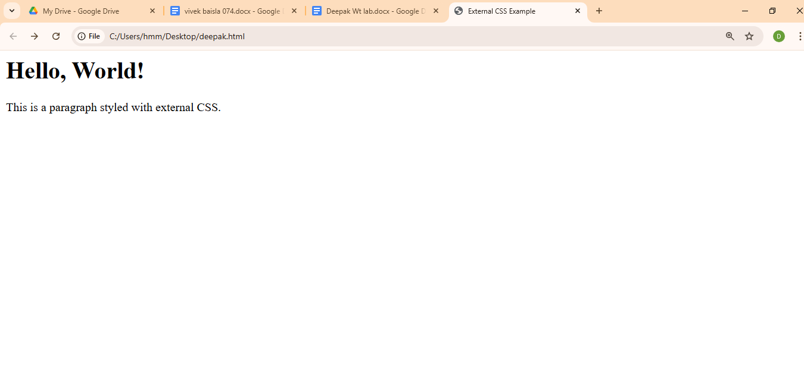

Q25. Write code to show Internal CSS with HTML code.

Input:

<!DOCTYPE html>

<html>

<head>

<title>Internal CSS Example</title>

</head>

<body>

<style>

body {

font-family: Arial, sans-serif;

background-color: lightblue;

}

h1 {

color: red;

text-align: center;

}

p {

color: green;

font-size: 18px;

}

</style>

<h1>Hello, World!</h1>

<p>This is a paragraph styled with internal CSS.</p>

</body>

</html>

Output:

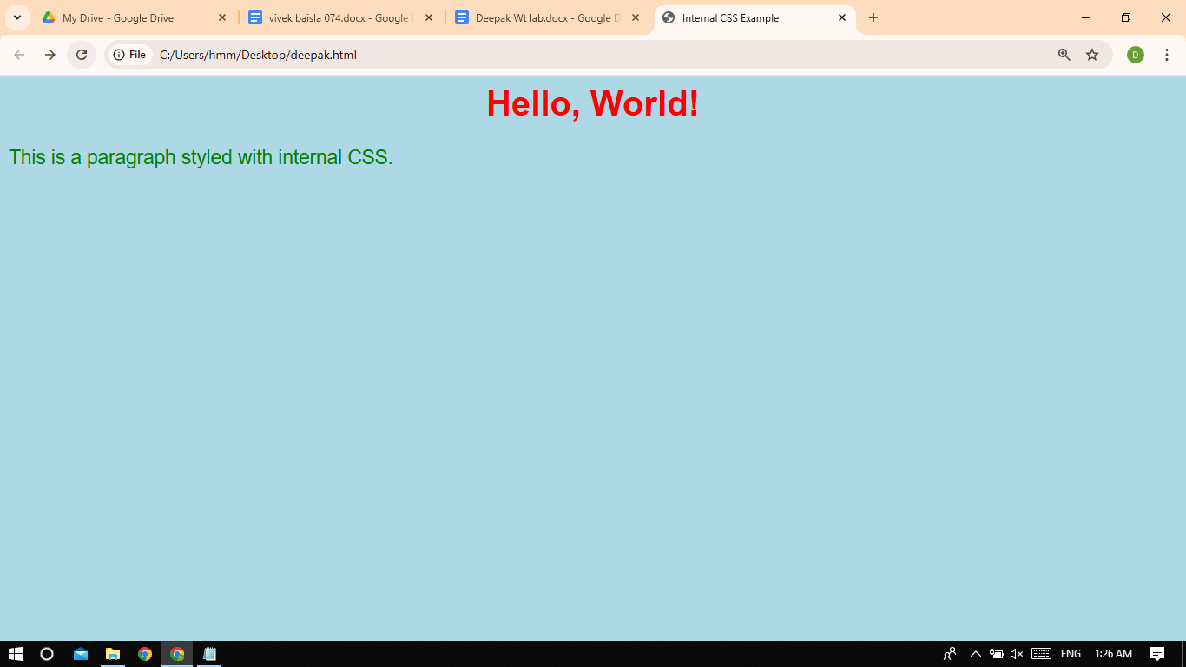

Q26. Write code to show Inline CSS with HTML code.

Input:

<!DOCTYPE html>

<html>

<head>

<title>Inline CSS Example</title>

</head>

<body>

<h1 style="color: red; text-align: center;">Hello, World!</h1>

<p style="color: green; font-size: 18px;">This is a paragraph styled with inline CSS.</p>

</body>

</html>

Output:

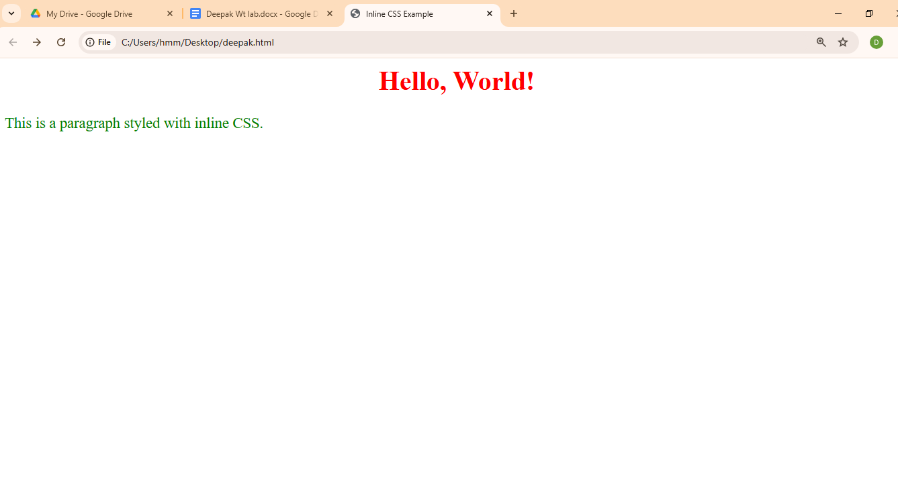

Q27. Write a program to add two numbers using form in JavaScript.

Input:

<html>

<body>

<script>

document.write(5 + 6);

</script>

</body>

</html>

Output:

